Project Design Phase-II

Customer (Requester) Journey Map
Date | 19 September 2026
Team ID | Shaik Irshad - 238W1A4256
Project Name | Automated Network Request Management In ServiceNow
Maximum Marks | 4 Marks

A customer journey map lays out, phase by phase, what a person experiences, thinks, and feels while going through a process — and where the biggest opportunities are to improve it. The map below traces the Requester's journey through the actual Network Request implementation, from first realizing they need a network connection through to seeing the final Approved/Rejected outcome.

Scenario: discovering, submitting, and tracking a network service request end to end, across the five phases Entice → Enter → Engage → Exit → Extend.

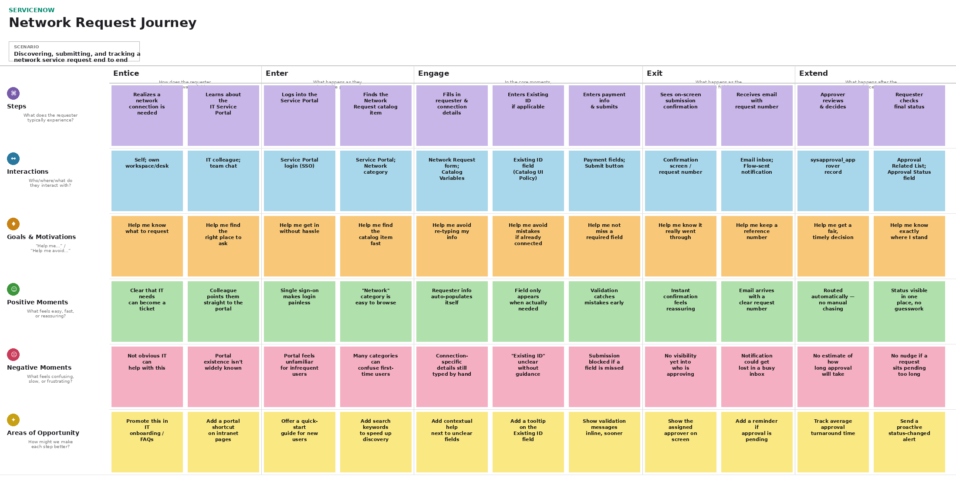
The Positive Moments and Negative Moments rows above are grounded directly in the project's problem statement (repetitive manual entry, unclear approval progress, uncertainty about submission, delays) and the objectives it was built to satisfy (standardized submission, auto-population, automated notification, and approval tracking). The Areas of Opportunity row reflects realistic, incremental improvements — not the larger future enhancements already tracked separately in the project's Brainstorming & Prioritization document (e.g. Cisco DNA/Ansible integration, multi-level approval, reporting dashboards).

